**Question 1:**

1. Creating Table in PostgreSQL -

1. Dashboard in Power BI -

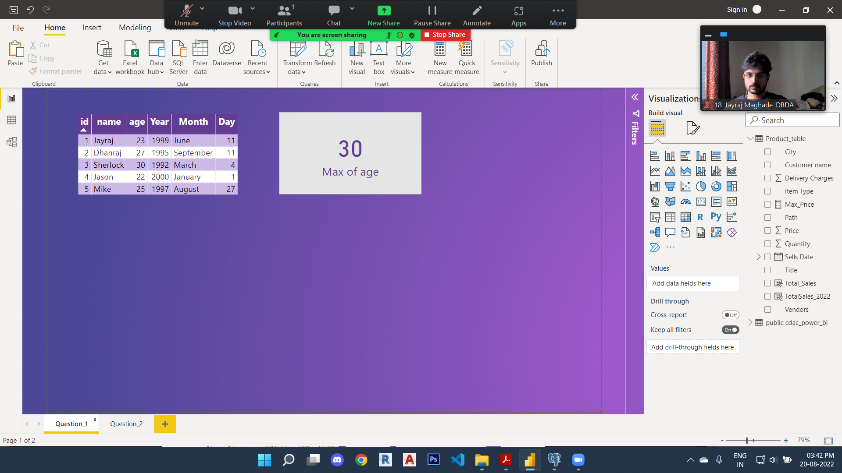

**Question 2:** Dashboard created in Power BI

